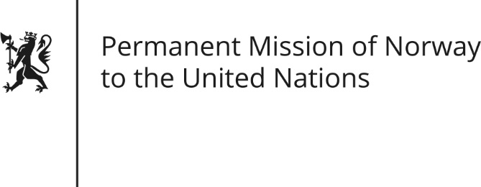

STATEMENT by Mr Paul Bjordal

Universal Periodic Review 27th Session. Review of the South Africa

10 May 2017

Check against delivery

The Norwegian delegation would like to thank the South African delegation for its presentation. Since the end of apartheid, South Africa has strongly supported the international human rights system, and its Constitution and democratic institutions enjoy international acclaim for the role they play in furthering human rights domestically.

Norway recommends South Africa build on its rule of law-tradition to actively combat corruption and other obstacles to the economic and social rights, civil and political rights of its people.

The UN Special rapporteur on violence against women reports that gender-based violence continues to be highly prevalent in South Africa. We recommend South Africa conduct a thorough investigation of the root causes of gender-based violence, and base future policy interventions on the results.

While South Africa has strong legal protection of LGBTI rights, the UN Special rapporteur on violence against women reports that lesbians and transgender persons in particular continue to be victims of violence. Norway recommends South Africa expedite the adoption of the Hate Crime and Hate Speech Bill, ensuring a strong legal framework against such crimes.

Norway notes that unacceptable conditions have been reported in some South African prisons and mental health institutions. We recommend South Africa ratify the Optional Protocol to the Convention against Torture, opening up for international inspections of places of detention.

Thank you.

